
Please download the pdf document in the resources section to view the emails you will need to investigate.

In your investigation of the emails, what signs did you find to indicate whether each email was malicious or safe? Give your opinion and analysis on these emails in this document, then upload it as your submission.

Here is an example to use as a reference point:
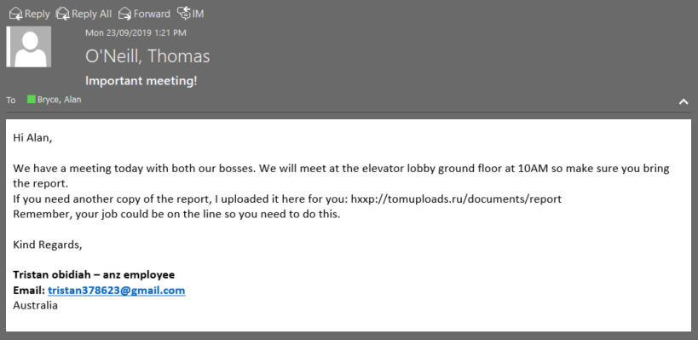

Example Answer (Please note this is not part of the Task and is an example only. Please remove this section from your task submission):

Is this email Safe or Malicious? | My Analysis
Malicious | - The attached URL is from Russia.  - The email sender is requesting the user download a file with fairly generic justification.  - This is enough indicators for us to assume that the link is probably malicious and should be treated as such.  - Overall the email is not very professional. It is far too generic using terms that could apply to almost anyone and anywhere such as “the report” and the job title of “anz employee”. Also ‘anz’ is not capitalized, and the email provided is not a business email.  - The name the email uses isn’t consistent with the display name.  - Finally the email tries to instill a sense of urgency and dread by mentioning that the person’s job is on the line, and mentioning their bosses to provide some sort of authority to what they are saying. This is a common form of social engineering.

Email 1:

Is this email Safe or Malicious? | My Analysis
Safe | It seems normal and the email is a reply of the previous email. After all, the email doesn’t contain any suspicious link or attachment.

Email 2:

Is this email Safe or Malicious? | My Analysis
Malicious | - OneDrive has its official email account.  - The domain is from Russia.  - The link is highly possible to be malicious.  - The email is very informal. ADOBE PDF and SECURITY are all spelled in capital, which is not polite. The ‘o’ in office 365 should be capitalized. This can’t be from a service for its customer.

Email 3:

Is this email Safe or Malicious? | My Analysis
Malicious | - The ‘B’ in facebook is written as anotehr character.  - .opt is unusual.  - FB login link should be: https://www.facebook.com/login/web/

Email 4:

Is this email Safe or Malicious? | My Analysis
Malicious | - This Adam may not be malicious, but the email he forward may be.  - See more may contains the malicious link.  - i.massdrop.com is malicious

Email 5:

Is this email Safe or Malicious? | My Analysis
Malicious | - FBI aganet will never need a normal person’s email to help them.

Email 6:

Is this email Safe or Malicious? | My Analysis
Safe | - This is an internal email and it seems safe.

Email 7:

Is this email Safe or Malicious? | My Analysis
Malicious | It’s too obvious that this link is malicious.

